Complaints Policy: Academies

Next Update: Autumn 2023

Introduction

Cheshire Academies Trust has a strong commitment towards working in positive partnership with the whole school community. All of our schools aim to resolve all complaints at the earliest possible stage and are dedicated to continuing to provide the highest quality of education possible throughout the procedure. This policy provides the framework within which parents/carers of pupils at all academies within the Trust and non-parents/carers may raise a complaint and have confidence that it will be considered seriously and dealt with appropriately.

We aim to work with parents and carers to deal with concerns as informally as possible; ideally face to face with a member of staff at an appropriate time which has been mutually agreed. Our formal complaints procedure is only necessary if efforts to resolve a concern informally are unsuccessful.

This policy complies with requirements about handling complaints. These are contained in The Education (Independent School Standards) (England) Regulations 2014 (Schedule 1, Part 7).

Employees should use the grievance policy to raise a complaint.

Policy Principles

- To encourage resolution of problems by informal means wherever possible
- To be easily accessible and publicised
- To be simple to understand and use
- To be impartial
- To be non-adversarial
- To allow swift handling with established time-limits for action and keeping people informed of the progress
- To ensure a full and fair investigation by an independent person where necessary
- To respect people’s desire for confidentiality (no use of social media to highlight complaint)
- To address all the points at issue and provide an effective response and appropriate redress

This procedure will be relied upon in respect of all complaints against individual academies within the Trust or the Trust itself except in the following areas, where separate policies and procedures exist:

- Child protection allegations
- Exclusions
- Admissions

Details of these policies and procedures can be found on the website for each academy in the Trust.

How to raise a concern or make a complaint
A concern or complaint can be made in person, in writing or by telephone. They may also be made by a third party acting on behalf of a complainant, as long as they have appropriate consent to do so. Complaints against school staff (except the Headteacher) should be made in the first instance, to the Headteacher via the school office. Please mark them as Private and Confidential.

Complaints that involve or are about the Headteacher should be addressed to the Chair of Governors, via the school office. Please mark them as Private and Confidential.

Complaints about the Chair of Governors, any individual governor or the whole governing body should be addressed to the Clerk to the Governing Body via the school office. Please mark them as Private and Confidential.
Complaints about the Chief Executive Officer (CEO) or a trustee of the Trust, should be addressed to the Chair of Trustees, via the trust office. Please mark them as Private and Confidential.
A template complaint form is included at the end of this policy. If you require help in completing the form, please contact the school office. You can also ask a third-party organisation to help you, for example, the Citizens Advice Bureau.
In accordance with equality law, we will consider making reasonable adjustments if required, to enable complainants to access and complete this complaints procedure. For instance, providing information in alternative formats, assisting complainants in raising a formal complaint or holding meetings in accessible locations.

Timescale

Complaints are to be made within 3 months of the incident or, where a series of associated incidents have occurred, within 3 months of the last of these incidents. We will consider complaints made outside of this timeframe if exceptional circumstances apply.

Stages of Complaint for Parents/Carers

There are 4 stages to the complaint procedure for parents/carers of pupils at the academy. Stage 1 is informal. Stages 2, 3 and 4 are formal. Complainants who have missed out stages in the procedure will be referred back to the appropriate stage.

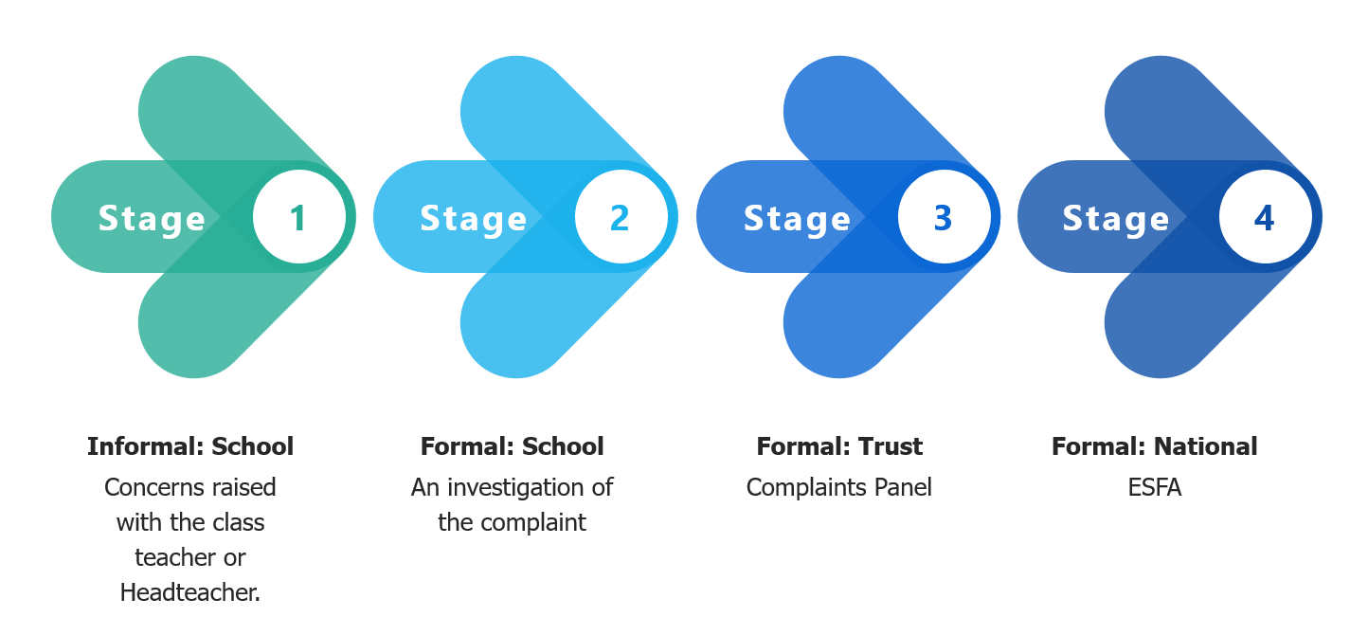
Stage One A  Informal: School | If you have concerns about any aspect of your child’s education and/or welfare you should first raise these concerns with the class teacher, their immediate manager or a senior manager in an attempt to resolve the issue. This can be done by seeing the member of staff at the end of the school day or by telephoning the school office to make an appointment.
Stage One B  Informal: School | If the issue cannot be resolved with the class teacher, please contact the Headteacher  (or the Chair of the Local Governing Body and CEO if the complaint is about the Headteacher) who will further investigate your concerns and respond within ten (10) school days.
Stage Two  Formal: School | If you are not satisfied after Stage 1, please use the form attached to this policy at and return it to the Chair of the Local Governing Body. The email address can be found on the school website.  Upon receipt of a completed formal complaint form, the Chair of the Local Governing Body will consult with the Chief Executive Officer (CEO) and both will identify the most appropriate person to investigate the complaint under stage 2. They may, as they think appropriate, identify a member of staff, a governor or trustee to investigate the complaint at this stage. The Chair of Local Governing Body will confirm to the complainant, the Headteacher and the CEO who will be investigating the stage two complaint. The CEO will not have any direct involvement with the complaint at this stage and will simply act as an advisor to the Chair of the Local Governing Board to identify the most appropriate person to investigate the complaint.  The Chair of the Local Governing Body will take into account any reasonable representations made by a Complainant that he or she would have difficulty discussing a complaint with a particular person. In these cases, the matter will be referred back to consult with the CEO and, if both feel it necessary, refer the complaint to another person. The investigation will be completed within 10 school days and the outcome of the investigation will be communicated in writing to the complainant and the Headteacher.  During a standard investigation the investigator should:  - Ensure that the complainant has the opportunity to submit witness statements which should be received in writing in support of their complaint.  - Keep a written record of any meetings/interviews in relation to their investigation.  You have fifteen (15) school working days to consider the decision. If no response is received by the academy within fifteen (15) school working days, it will be deemed that the decision is accepted and the case will be closed. If, however, you are not satisfied with the response received from stage 2 of the process, you may proceed to Stage 3 of the complaint process but must do so within fifteen (15) school working days of the response.  If the complaint is about the Headteacher, or a member of the governing body (including the Chair or Vice-Chair), a suitably skilled governor will be appointed to complete all the actions at Stage 2.  Complaints about the Headteacher or member of the governing body must be made to the Clerk, via the school office.  If the complaint is:  · jointly about the Chair and Vice Chair or  · the entire governing body or  · the majority of the governing body  Stage 2 will be escalated to the CEO of the Trust.
Stage Three  Formal: Trust | If you are unhappy with the outcome of the complaint under Stage 2, you should write to the CEO at info@cheshireacademiestrust.co.uk and ask for the complaint to be considered under Stage 3 of this Complaints Policy.  The CEO will acknowledge the complaint within five (5) working days of the date that the written request was received.  At Stage 3 a Complaints Panel of at least three (3) people who were not directly involved in the matter being complained about, one of whom must be independent of the management and running of the school and one of whom must be a member of the Board of Trustees of Cheshire Academies Trust, will hear the complaint within fifteen (15) school working days. This is to consider the issues and merits of the complaint and not to merely address whether due process was completed satisfactorily at Stage 2.  Neither the Headteacher, staff member or the Chair of the Local Governing Body of the relevant academy can be members of the panel.  If the complaint is:  · jointly about the Chair and Vice Chair or  · the entire governing body or  · the majority of the governing body  Stage 3 will be heard by the trustees and an independent panel member.  If the complaint concerns the CEO or a Trustee, the complaint should be investigated by the Chair of the Trust Board. If a formal complaint is received about the Chair, the complaint will be referred to the Vice Chair for investigation.  If the complaint is:  · jointly about the Chair and Vice Chair or  · the entire trust board or  · the majority of the trust board  Stage 3 will be heard by a completely independent committee panel.  The Complaints Panel is the last academy/Trust-based stage of the complaints process, and is not convened to merely rubber-stamp previous decisions.  The panel may regulate its own procedure and implement a process at this stage which is appropriate to the complaint being made. You will be entitled to attend the panel hearing and be accompanied if you so wish. This meeting will be clerked and those concerned will be allowed to bring witnesses if this is appropriate. The panel will give a decision in writing without delay or within ten (10) school working days of the hearing to you. A copy of the decision will be forwarded to any persons who are the subject of your complaint and the Headteacher.  The findings and recommendations of the panel will be available for inspection on the school premises by the proprietor and the Headteacher. The academy will keep a written record of all complaints made in accordance with sub-paragraph (e) of The Education (Independent School Standards) (England) Regulations 2014 (Schedule 1, Part 7), along with details of whether they were resolved following a formal procedure, or progression to a panel hearing. The academy records will note the action taken as a result of complaints (regardless of whether they are upheld).  All correspondence, statements and records relating to individual complaints are kept confidential except where the Secretary of State or a body conducting an inspection under section 109 of the 2008 Act requests access to them.  * No meetings will be tape recorded. This will be stated at the commencement of the panel hearing and that if the complainant does still go ahead and records the meeting it will not be considered as part of the investigation of the complaint.
Stage Four  Formal | The results of the hearing will be final and following ratification of the outcome, you will be advised that the matter is closed as far as the academy/Trust is concerned.  Complaints about the school failing to comply with this procedure or failing to comply with the obligations in its Funding Agreement with The Secretary of State for Education may be made to the Education and Skills Funding Agency (ESFA). The ESFA will consider complaints that fall into any of the following three categories:  1. where there is undue delay or the school does not comply with its own complaints procedure when considering a complaint  2. where the academy is in breach of its funding agreement with the Secretary of State  3. where an academy has failed to comply with any of its legal obligation  The ESFA will normally only consider complaints when every stage of the above process has been completed.  Further details can be found at www.education.gov.uk/aboutdfe/complaintsprocedure

Academy Complaint Procedure for Non-Parents/Carers
If you have concerns about the academy, please raise these concerns with the Headteacher in an attempt to resolve the issue by telephoning the school office to make an appointment. If you are not satisfied by the response, write to the Chair of the Local Governing Body in a sealed envelope with ‘confidential’ written on it via the academy office and s/he will arrange for the complaint to be investigated and respond within ten (10) school working days. The Chair should contact the CEO and together should decide who is most appropriate to undertake an investigation. There is no right to appeal at the end of this stage.

Investigating Complaints
At each stage of the investigation process, the person investigating the complaint ensures that they:

- establish what has happened so far, and who has been involved;
- clarify the nature of the complaint and what remains unresolved;
- meet with the complainant or contact them (if unsure or further information is necessary);
- clarify what the complainant feels would put things right;
- interview those involved in the matter and/or those complained of, allowing them to be accompanied if they wish;
- conduct the interview with an open mind and be prepared to persist in the questioning; and
- keep notes of the interview.

Resolving Concerns and Complaints

When there are particular concerns which complainants wish to share, the school encourages them to contact the school by telephone or email/letter so that the matter can be dealt with quickly and informally.

For clarity: there is a difference between a concern and a complaint.

- Concerns ought to be handled, if at all possible, without the need for formal procedures.
- Complaints will be dealt with openly, fairly, promptly and without prejudice.
- The Academy reserves the right to treat communications with parents as formal complaints even if parents/carers do not request this in the communication.

At each stage in the complaints procedure academies will keep in mind ways in which a concern or complaint can be resolved. It might be sufficient to acknowledge that the complaint is valid in whole or in part. In addition, it may be appropriate to offer one or more of the following, an:

- apology;
- explanation as to why something happens in the way it does;
- admission that the situation could have been handled differently or better;
- assurance that the event complained of will not recur;
- explanation of the steps that have been taken to ensure that it will not happen again;
- undertaking to review school policies in light of the complaint.

Serial and Vexatious Complaints

There will be occasions when, despite all stages of the procedure having been followed, the complainant remains dissatisfied and nothing further can reasonably be done to assist the complainant or to rectify an actual or perceived issue. If the complainant tries to reopen the same or substantially the same issue or any other issue where the Chair of the Local Governing Body reasonably believes that the aim of the complainant is to cause stress to the academy or is unreasonably made, the Chair of the local governing body will inform them in writing that the procedure has been exhausted and that the matter is now closed in accordance with the following procedure:

Stage 1- if the communication/complaint from a single person meets our definition of a serial or vexatious complaint (as set out in the Trust’s Policy for Managing Serial and Vexatious Complaints), a warning letter will be issued setting this out and expressing a view that if the behaviour does not change, we will deem the complaints serial or vexatious and that a person's right to communicate with the school will be restricted.

Stage 2 - if the behaviour continues, the following restrictions will be put in place - email contact via a specific address or communication in writing only; meetings with two members of staff; calls to a specific person; no need to acknowledge letters, emails and text messages. As long as parents still receive necessary information about the child, the other restrictions are within the academy’s discretion. If the communication becomes threatening or harassing, then police involvement/action under the Protection from Harassment Act 1997, would have to be considered.

Identifying a serial and vexatious complaint

Complaints may be deemed to be serial or vexatious where they meet one of more of the criteria set out in the Trust’s Policy for Managing Serial and Vexatious Complaints. The Trust’s Policy for Managing Serial and Vexatious Complaints can be accessed via the link below via the Trust website.

www.cheshireacademiestrust.co.uk

The decision to categorise a complaint as serial or vexatious will be made by the Headteacher together with the Chair of the Local Governing Body and CEO. This will only be actioned as a last resort and after all reasonable steps have been taken to assist the complainant.

Publication of Procedure

This procedure will be made available on the website for each academy in Cheshire Academies Trust and will be made available to anyone who asks for it.

Appendix 1
Cheshire Academies Trust

Academy Complaints Procedure for Parents/Carers of Pupils

Please complete and return to info@cheshireacademiestrust.co.uk.

Your name
Child’s name Year Group
Your relationship to the child
Address

Telephone number (daytime) (evening)
Please give details of your complaint

(Include details of actions already taken by the school to try to resolve the situation)

What actions do you feel might resolve the problem at this stage?

Are you attaching any paperwork? If so please give details.

Signature

Date

Official Use by Academy

Date acknowledgement sent:

By Whom?

Complaint referred to:

Date:

All functions of the complaints procedure must adhere to the requirements of the Data Protection Act 2018 and the Freedom of Information Act 2000.

