MANOR PARK SCHOOL AND NURSERY

RELATIONSHIP AND SEX EDUCATION POLICY

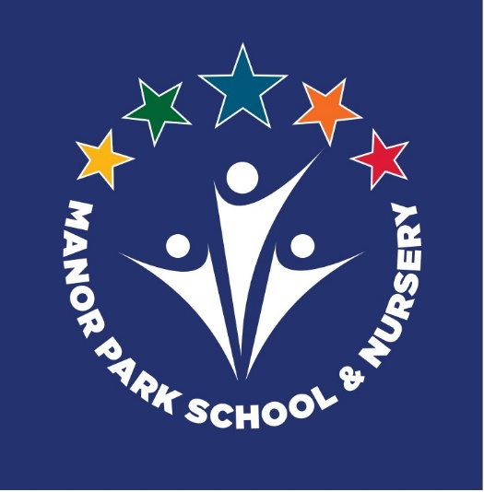

The Relationship and Sex education Policy in respect of Manor Park
Primary School has been discussed and adopted by the Governing
Body

Last updated: January 2023
To be reviewed: January 2025

PERSON RESPONSIBLE FOR POLICY: | Sarah Jeffery
APPROVED:
signed:
to be reviewed: | January 2025

Introduction

From September 2020, pupils receiving primary education must be taught Relationships Education, under the Relationships Education, Relationships and Sex Education, and Health Education (England)Regulations 2019. This policy framework should be read in conjunction with the DfE guidance regarding relationships and sex education. Its purpose is to enable Manor Park Primary School and Nursery to develop an effective Relationship and Sex Education Policy, using the framework set out below.
Statutory requirements

As a primary school we must provide relationships education to all pupils as per section 34 of the Children and Social work act 2017.
However, we are not required to provide sex education but we do need to teach the elements of sex education contained in the science curriculum.
In teaching RSE, we must have regard to guidance issued by the secretary of state as outlined in section 403 of the Education Act 1996.
At Manor Park we teach RSE as set out in this policy

Aims and Objectives of this Policy
The aims of relationships and sex education (RSE) at Manor Park School and Nursery are to:
- Provide a framework in which sensitive discussions can take place
- Prepare pupils for puberty, and give them an understanding of sexual development and the importance of health and hygiene
- Help pupils develop feelings of self-respect, confidence and empathy
- Create a positive culture around issues of sexuality and relationships
- Teach pupils the correct vocabulary to describe themselves and their bodies
- Ensure pupils at Manor Park are fully aware of the protected characteristics of the Equalities Act
- Ensure sensitivity to context of the Manor Park community

Curriculum
Our curriculum is set out as per Appendix 1 but we may need to adapt it as and when necessary to meet the needs of our pupils and fulfil the changing requirements as laid out by the Department for Education.
We have developed the curriculum in consultation with parents, pupils and staff, taking into account the age, needs and feelings of pupils. If pupils ask questions outside the scope of this policy, teachers will respond in an appropriate manner so they are fully informed and don’t seek answers online which can make them vulnerable to misinformation. Teachers will endeavor to answer questions as honestly as possible but if faced with a question they do not feel comfortable answering within the statutory guidance, or a question that takes the pupils beyond the learning of the primary age range, provision would be made to meet the individual child’s needs. This may involve referring the child back to their parent/carer, school health advisor/school nurse for an answer or seeking advice from the PSHE coordinator or senior pastoral lead.
Primary sex education at Manor Park will focus on the statutory content:

- Preparing boys and girls for the changes that adolescence brings
- Human reproduction; how a baby is conceived and born
For more information about our curriculum, see our curriculum map in Appendix 1

Delivery of RSE
RSE is taught within the personal, social, health and economic (PSHE) education curriculum. Biological aspects of RSE are taught within the science curriculum, and other aspects are included in religious education (RE). Pupils also receive stand-alone sex education sessions, these may be delivered by a trained health professional. Relationships education focuses on teaching the fundamental building blocks and characteristics of positive relationships including:
- Families and people who care for me
- Caring friendships
- Respectful relationships
- Online relationships
- Being safe
For more information about our RSE/PSHE curriculum, see Appendices 1 and 2.
As the statutory guidance outlines, these areas of learning are taught within the context of family life taking care to ensure that there is no stigmatisation of children based on their home circumstances (families can include single parent families, LGBT parents, families headed by grandparents, adoptive parents, foster parents/carers amongst other structures) along with reflecting sensitively that some children may have a different structure of support around them (for example: looked after children or young carers).
Roles and responsibilities
The governing board The governing board will approve the RSE policy, and hold the Headteacher to account for its implementation.
The Headteacher
The Headteacher is responsible for ensuring that RSE is taught consistently across the school. Parents do have the right to withdraw pupils from sex education which is non-statutory/non-science components of RSE. Relationships education is statutory for all pupils (see section 8), as such, parents have no right to withdraw from any element of the content taught at Manor Park as the only content which will be delivered is that which is statutory.
Staff
Staff are responsible for:
- Delivering RSE in a sensitive way
- Modelling positive attitudes to RSE
- Monitoring progress of pupils
- Responding to the needs of individual pupils
- Responding appropriately to pupils who raise questions about the content of the RSE curriculum in line with this policy and sharing this information with parents
- Responding to parents who raise concerns about the content of the RSE curriculum, this may involve referring to senior staff
Staff do not have the right to opt out of teaching RSE. Staff who have concerns about teaching RSE are encouraged to discuss this with the Headteacher.
At Manor Park, the subject lead for RSE is Mrs Jeffery. Relationships education is taught by all teaching staff through PSHE lessons. Where discrete lessons take place for Healthy Relationships and for education about puberty, these may be taught by specialist agencies where available and the School Nurse team.
Pupils As with all curriculum subjects, pupils are expected to engage fully in RSE and, when discussing issues related to RSE, treat others with respect and sensitivity.
Parents’ right to withdraw
Parents do not have the right to withdraw their children from relationships education. Parents have the right to withdraw their children from the non-statutory/non-science components of sex education within RSE. At Manor Park, no non statutory sex education is taught.
Training
Staff are trained on the delivery of RSE as part of their induction and it is included in our continuing professional development calendar. The Headteacher will also invite visitors from outside the school, such as school nurses or healthy relationships professionals, to provide support and training to staff teaching RSE where appropriate.
Monitoring arrangements
The delivery of RSE is monitored by senior leaders in school through a variety of monitoring methods; learning walks, pupil interviews, book checks, planning checks. Pupils’ development in RSE is monitored by class teachers as part of our internal assessment system.
This policy will be reviewed by the RSE lead biannually.
Context of our Community and LGBTQ content

Every effort will be made to deliver the RSE curriculum in a sensitive manner, understanding the concerns of our local community. It is the desire of the working party who have been developing this policy, that the RSE curriculum will be clear in supporting pupils’ understanding of the protected characteristics under the Equalities Act.
We want children to understand the context of their learning. They will learn about the rule of law and that same sex marriage is legal in Britain. They will learn about the many different types of families and different adult choices about relationships and that all of these must be shown respect. We want all of our children to understand the importance of valuing the choices of others. This includes the choices and teachings of the religious community that they or others belong to, as an additional protected characteristic, and how all people making these different choices can live together harmoniously and respectfully.
Crucially, we want children to understand the harm that offensive language related the LGBTQ community causes and to understand the importance and value of kindness in the way we address and talk about people who are different to ourselves. Children will learn about homophobic bullying within the context of many forms of different bullying. They will learn about the inappropriate use of terms to denote sexual preferences and where these are used as insults, they would be classed as examples of homophobia.

Resources
At Manor Park, we will be using themed narrative texts to explore issues within the RSE curriculum. These books are categorised into key themes and will be used as starters to new topics in classes.
Our book list can be seen in the appendix. Books will be taught as part of a guided shared reading session, and not for general use in the library. This will ensure children are well supported with any questions they may have, and that class teachers can be aware of any questions which arise which may be referred to parents.

Appendix 1

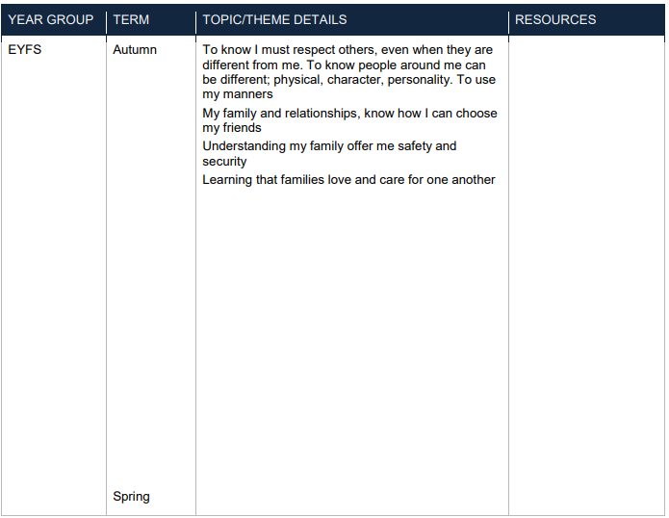
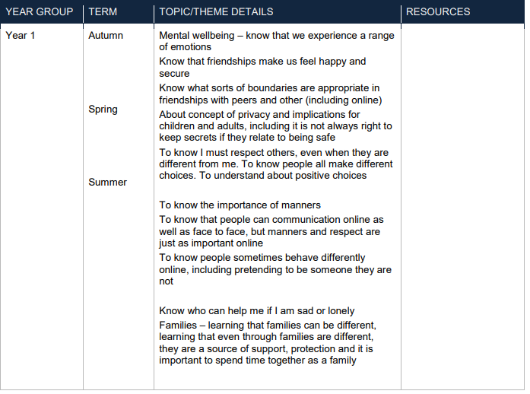
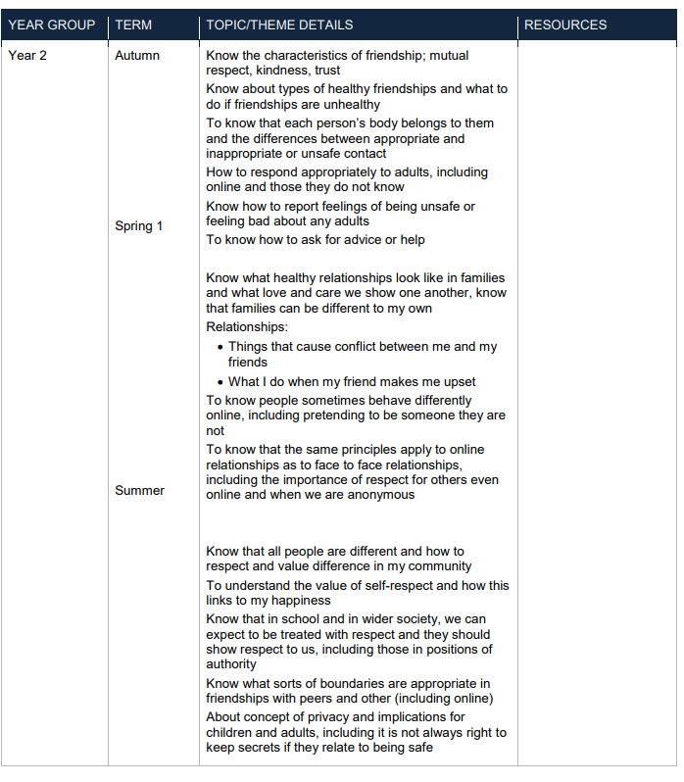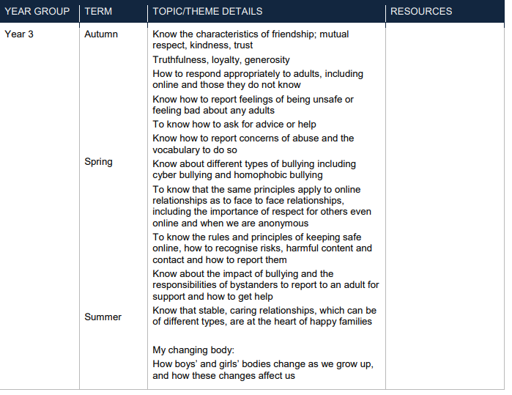

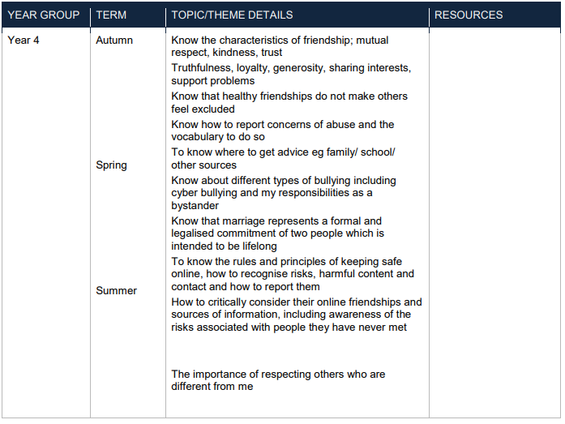

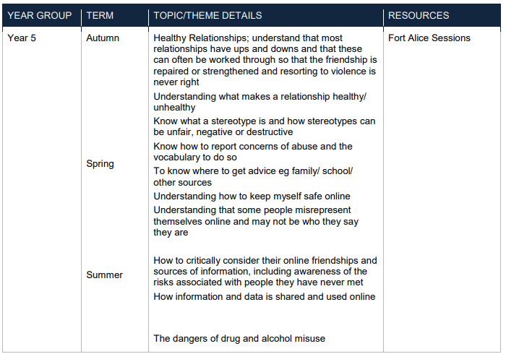

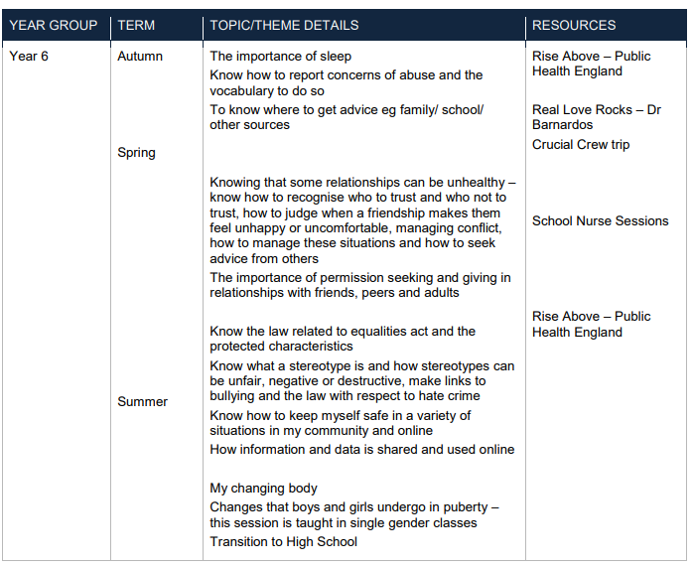

Appendix 2

