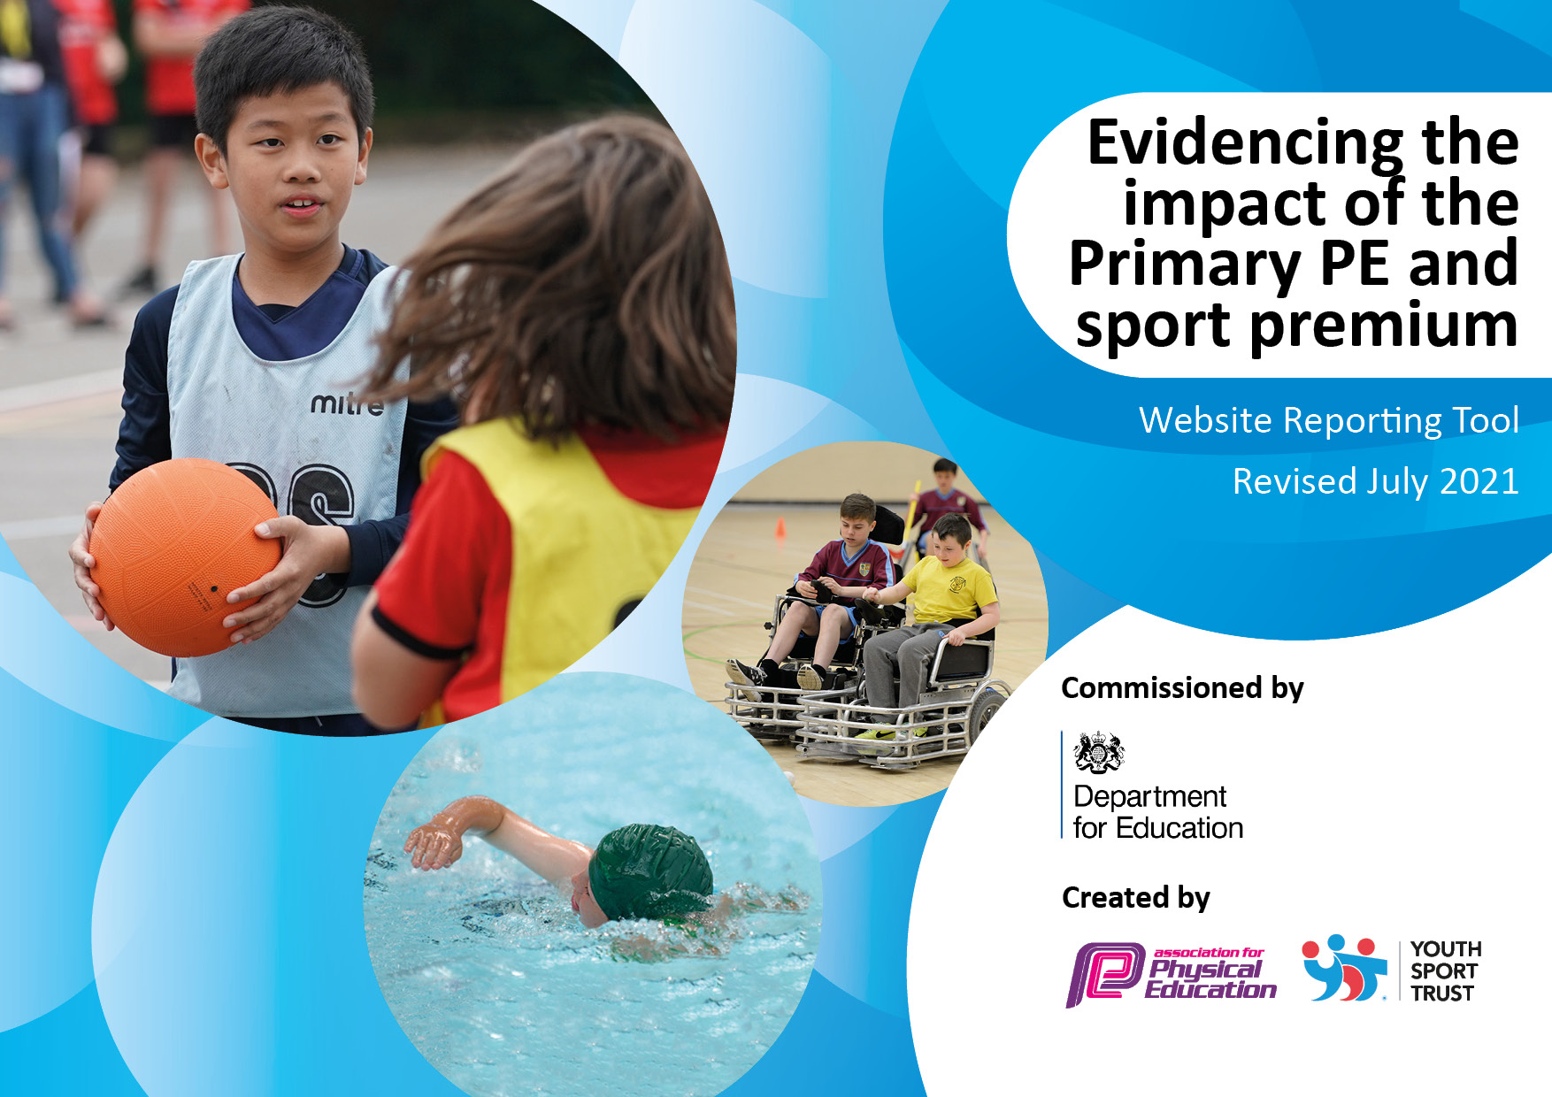
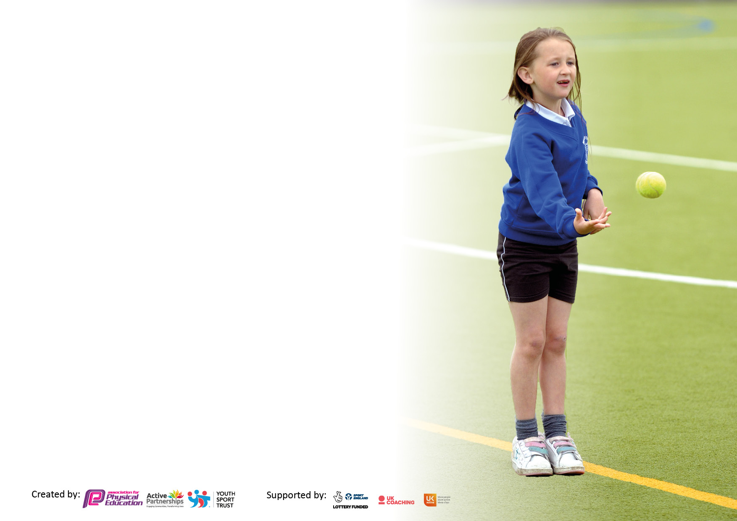

It is important that your grant is used effectively and based on school need. The Education Inspection Framework makes clear there will be a focus on ‘whether leaders and those responsible for governors all understand their respective roles and perform these in a way that enhances the effectiveness of the school’.

Under the Quality of Education Ofsted inspectors consider:
Intent - Curriculum design, coverage and appropriateness
Implementation - Curriculum delivery, Teaching (pedagogy) and Assessment
Impact - Attainment and progress

To assist schools with common transferable language this template has been developed to utilise the same three headings which should make your plans easily transferable between working documents.

Schools must use the funding to make additional and sustainable improvements to the quality of Physical Education, School Sport and Physical Activity (PESSPA) they offer. This means that you should use the Primary PE and sport premium to:

- Develop or add to the PESSPA activities that your school already offer
- Build capacity and capability within the school to ensure that improvements made now will benefit pupils joining the school in future years
- The Primary PE and sport premium should not be used to fund capital spend projects; the school’s budget should fund these.

Pleasevisitgov.ukfortherevisedDfEguidanceincludingthe5keyindicatorsacrosswhichschoolsshoulddemonstrate animprovement.Thisdocumentwillhelpyoutoreviewyourprovisionandtoreportyourspend.DfEencouragesschools to use this template as an effective way of meeting the reporting requirements of the Primary PE and sport premium.

We recommend you start by reflecting on the impact of current provision and reviewing the previous spend.

Schools are required to publish details of how they spend this funding, including any under-spend from 2019/2020, as well as on the impact it has on pupils’ PE and sport participation and attainment. All funding must be spent by 31st July 2022.

We recommend regularly updating the table and publishing it on your website throughout the year. This evidences your ongoing self-evaluation of how you are using the funding to secure maximum, sustainable impact. Final copy must be posted on your website by the end of the academic year and no later than the 31st July 2021. To see an example of how to complete the table please click HERE.
Created by: Supported by:

Manor Park School and Nursery
Primary PE and Sports Premium Review and Plan 2022-23

Key achievements to date: | Areas for further improvement and baseline evidence of need:
The successful continued improvement of the environment and resources in collaboration with OPAL at Manor Park - OPAL is an award-winning, mentor supported school improvement programme that addresses all the areas that schools must plan for if they want to strategically and sustainably improve the quality of their play opportunities.  The continuation of external coach expertise for both CPD and ASC – ASM  The provision of a very exciting and successful sports week – June 2023  Extensions to the outdoor trim trail, climbing walls and OPAL provision.  Continued collaboration with KMAT looking forward to participating in competition with local schools. | Continued investment to ensure growth of resources and equipment for OPAL  Include a broader range of activities and experiences across the year via club and within the curriculum ie Martial Arts.  Familiarise and begin to use the portal system provided by ASM for assessment.  As the sports week was such a successful event, we intend to make it an annual event and make improvements year on year. The timing for different events needs to be shortened and we would like to have more external agencies involved.  Have a full year of involvement with KSSP  Identify children who do not fully engage in PE and potential barriers. Enable full inclusion and participation of children in line with the school improvement plan.

Total amount carried over from 2019/20 | £0
Total amount allocated for 2022/23 | £17845
How much (if any) do you intend to carry over from this total fund into 2023/24? | £0
Total amount allocated for 2022/23 | £17845
Total amount of funding for 2022/23. To be spent and reported on by 31st July 2023 | £17845
Swimming Data

Meeting national curriculum requirements for swimming and water safety.

N.B. Complete this section to your best ability. For example you might have practised safe self-rescue techniques on dry land which you can then transfer to the pool when school swimming restarts.
Due to exceptional circumstances priority should be given to ensuring that pupils can perform safe self-rescue even if they do not fully meet the first two requirements of the NC programme of study
What percentage of your current Year 6 cohort swim competently, confidently and proficiently over a distance of at least 25 metres?  N.B. Even though your pupils may swim in another year please report on their attainment on leaving primary school at the end of the summer term 2022.  Please see note above | NA
What percentage of your current Year 6 cohort use a range of strokes effectively [for example, front crawl, backstroke and breaststroke]?  Please see note above | NA
What percentage of your current Year 6 cohort perform safe self-rescue in different water-based situations? | NA
Schools can choose to use the Primary PE and sport premium to provide additional provision for swimming but this must be for activity over and above the national curriculum requirements. Have you used it in this way? | Yes/No

Action Plan and Budget Tracking
Capture your intended annual spend against the 5 key indicators. Clarify the success criteria and evidence of impact that you intend to measure to evaluate for pupils today and for the future.

Academic Year: 2022/23 | Total fund allocated: £17,845 |  | Date Updated: July 2023
Key indicator 1: The engagement of all pupils in regular physical activity – Chief Medical Officers guidelines recommend that primary school pupils undertake at least 30 minutes of physical activity a day in school |  |  |  |  |  | Percentage of total allocation:
 |  |  |  |  |  | %
Intent | Implementation |  |  |  | Impact
To continue to improve and ensure growth of the OPAL scheme to enhance play and physical activity during break and lunchtimes. Scooters, beach hut, beach provision, etc. | Children will be encouraged to participate in a variety of physical play during lunch and playtimes. |  | £2000 |  | Children will be developing physically through play and enjoyment. | 11%
Provide children who struggle with fine and gross motor skills and confidence specific support to help them to develop their confidence in PE and the classroom setting. | Identify children who need additional support with PE and confidence with PE and the classroom setting. |  |  |  | Children are more confident and are showing improvement in their find and gross motor skills.
Weekly staff CPD sessions and after school clubs .  Focus on KS1 and KS2 fitness to improve stamina.  Continue to improve additional aspects of gross and fine motor skills from Early years upwards. | Warm up sessions will partly be formed by a middle-distance run followed by a planned lesson.  Additional resources obtained and used to promote specific areas of physical development. Example basketball nets, dodgeballs, scooters. |  | £5600  £1644,37 |  | Children will have increased fitness and stamina and will build over the course of the year.  Children use the resources that are targeted for specific areas of physical development, for example balance bikes/scooters. | 31%  9%
Key indicator 2: The profile of PESSPA being raised across the school as a tool for whole school improvement |  |  |  |  |  | Percentage of total allocation:
 |  |  |  |  |  | %
Intent | Implementation |  |  |  | Impact
To implement the OPAL scheme to enhance play during break and lunchtimes.  Audit OPAL provision to enhance impact. | Using the mentor system playleaders and OPAL leaders will have regular meetings/training to learn how to use the equipment and to change the mindset of play and risk.  Source and purchase large sunken trampoline for school field.  (Include work carried out by Aitchisons prior to fitting)  Source and purchase quality scooters to replace old broken ones. |  | See above  £1,800 |  | Every school child will have an amazing playtime every day with no exceptions.  OPAL is here to stay and has been incredibly well received by children, parents and staff.  Many items have been donated to OPAL by way of a ‘non-uniform day- and an open-day on Saturday  Our school has been awarded ‘Platinum’ for our OPAL provision which is testament to all the hard work and investment into this scheme. | 10%
Children in KS2 to have a greater experience and confidence in leading others. | ASM to work with KS2 and Nursery teacher to plan and deliver lessons whereby the older children lead and teach the younger children.
Children to continue to have access to the school Sports kit as required for external sporting events.  Quality PE lessons provided by the specialist PE coach (ASM) throughout the year. | Kit with the new school logo now needs to be ordered for future multiple events. The response to the new kit has been very positive.  Weekly lessons delivered by the specialist coaches. Teachers also providing additional lessons to ensure progression of skills and improvement in overall fitness. |  | See above |  | Children who represent the school use the kit and look exceptionally smart. Having the kit raises their self-esteem and well-being.

Key indicator 3: Increased confidence, knowledge and skills of all staff in teaching PE and sport |  |  |  | Percentage of total allocation:
 |  |  |  | %
Intent | Implementation |  | Impact
Your school focus should be clear | Make sure your actions to | Funding | Evidence of impact: what do | Sustainability and suggested
what you want the pupils to know | achieve are linked to your | allocated: | pupils now know and what | next steps:
and be able to do and about | intentions: |  | can they now do? What has
what they need to learn and to |  |  | changed?:
consolidate through practice:
Children learn and improve their skills through consistently high-quality PE. | Staff meeting provided by ASM with a particular focus on DANCE will be delivered in the Spring term (15th Feb). | £150 | Children are very active and engaged in PE lessons and they are confident that they are learning. They feel like they are always learning new skills and being challenged in exciting and enjoyable lessons. | .8%
Key indicator 4: Broader experience of a range of sports and activities offered to all pupils |  |  |  | Percentage of total allocation:
Intent | Implementation |  | Impact
Remain invested in the KMAT partnership with other local primary schools. | Participate in the Knutsford Multi-Academy Trust (KMAT) events that are held throughout the year. | £1,300 | Children are given the opportunity to compete against other children within their own year group. | 7%  This will continue in the next academic year.
Children experience new sports and activities that they have never tried before. Paralympic sports, blind line, crazy golf, tin can alley. | Organise and hold a sports week event to give all children a range of activities and experiences.  (Sports week held June 12th – 16th in the afternoons). | £2,100 (approx) | Children experience and enjoy new activities, which engages and encourages them to take part in that activity in future.  Sports week was a huge success and enjoyed by every child and staff member who took part.  Children have had the opportunity to learn new skills and the rules for new games – especially the summer games rounders and cricket. | 12%  This will be repeated in 2024. The adjustment of timings was well received and very successful.  Year on year we will endeavour to incorporate new skills and experiences within the curriculum.
Children to have a range of physical education experiences in conjunction with specialist experience. | Continue to employ external specialist coaches to deliver weekly lessons to all children. | See above
Children have the opportunity to participate in after-school clubs | Offer children after-school slots on a half-termly basis to give access to all children across the year. | £2800 | Again, this will continue throughout next year – with the consideration of new clubs and new experiences. | 16%
Total outgoings for 2022-23
£17,394

Key indicator 5: Increased participation in competitive sport |  |  |  | Percentage of total allocation:
 |  |  |  | %
Intent | Implementation |  | Impact
Your school focus should be clear | Make sure your actions to | Funding | Evidence of impact: what do | Sustainability and suggested
what you want the pupils to know | achieve are linked to your | allocated: | pupils now know and what | next steps:
and be able to do and about | intentions: |  | can they now do? What has
what they need to learn and to |  |  | changed?:
consolidate through practice:
 |  | £

Signed off by
Head Teacher:
Date:
Subject Leader:
Date:
Governor:
Date:

