Dear Parent or Carer, Friday 15th September 2023

Re: Attendance and absence reporting

Welcome back to the new school year. As you will be aware, attendance has always been high on the agenda at Manor Park and we have worked hard with you to improve our attendance and reduce the number of children who were persistently absent.

I am now asking for your support again in improving our whole school attendance and punctuality. It is vital that we make every school minute count. I urge you to ensure that your child is in school and on time every day to prevent anyone falling behind with their learning. In light of this, this reminder letter will provide you with a clear outline about absence procedures and the School and Local Authority responses to poor pupil attendance.

Types of Absence
Each absence is classed as authorised or unauthorised. Absences are coded as authorised where reasons are considered valid and unauthorised where no explanation or unacceptable reasons are given.

Unacceptable Reasons
The following reasons are not acceptable:

• shopping visits
• care for family members
• days out to theme parks or to attend concerts/shows
• parents’ work commitments or business trips
• birthdays
• feeling tired
• holidays taken in term time (including long weekends taken on Fridays and/or Mondays)
• parental illness
• bad weather

Illness and First Day Call
If your child is unable to attend school through illness, there are three steps which you should follow in relation to any absence planned or unplanned, brief or otherwise:
- Contact the school by telephone on the first morning of the absence (before 9am) and inform the school the reason for and expected length of the absence
- Keep the school informed if the absence is going to be more prolonged than initially anticipated
- On return to school provide the teacher with a written explanation for the absence (this is a required step) – letter, email or note in the child’s planner.
If you do not supply us with this information, we have a duty to contact you, so that we may be sure of the child’s whereabouts, as this is a safeguarding measure. Where the child is absent through illness or unavoidable medical appointments, this will normally be counted as authorised. However, we are unable to authorise absences on telephone communication alone. Our advice from the Attendance and Out of School Team is that absences can only be authorised if they are followed up in writing – either a letter, an e mail or a note in the child’s planner. If we do not receive notification in writing, the absence will remain unauthorised – even if the child was ill. This caused a few problems at the end of the last school year as parents realised their child’s absence had been identified as unauthorised. We therefore urge you to follow the guidelines so that confusion doesn’t occur at a later time.

It’s also important to be aware that if a child has less than 96% attendance, we will not be able to authorise any additional absences unless accompanied by medical evidence (this is information the school has to follow from the Attendance and Out of School Team).

Cheshire East Council have also made it clear to schools that they expect Fixed Penalty Notices to be issued in those instances where attendance does not improve. Therefore, in light of this, and with our continued aim to improve our attendance figures we have decided on the follow course of action.
Attendance falls below 96% - Letter informing parents of the school’s concern regarding attendance. Support will be offers through the Attendance Officer and Pastoral Team.
Attendance will be monitored for a further 4 weeks after the meeting. If there is a continuation of poor unauthorised attendance at school, the case will be passed onto Cheshire East Council who will decide whether to issue a Fixed Penalty Notice.
Attendance remains below 96% and 8 more sessions of absence are unauthorised – Parents invited to an attendance Panel Meeting with the Attendance and Out of School Team in attendance. An action plan will be put in place. Parents will be informed about Fixed Penalty Notices which will be issued if there is no substantial improvement.
The information relating to Fixed Penalty Notices is detailed below.
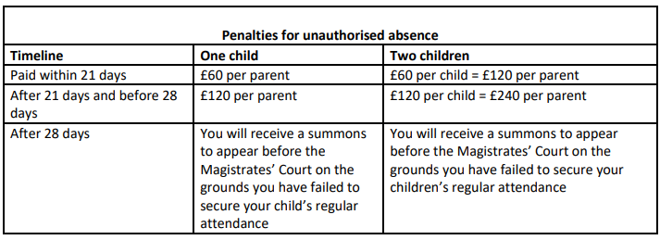

As a school our priority always is to support you and work with you and your child to ensure attendance improves. Therefore, if you are finding it difficult to improve the attendance of your child, please contact school to speak to myself or Mrs Thatcher (Attendance and Safeguarding Officer), so we can put strategies in place to help you before we reach the situation outlined above.

Yours sincerely,

Mrs S Jeffery
Deputy Head Teacher

