MANOR PARK SCHOOL AND NURSERY

PHONICS POLICY

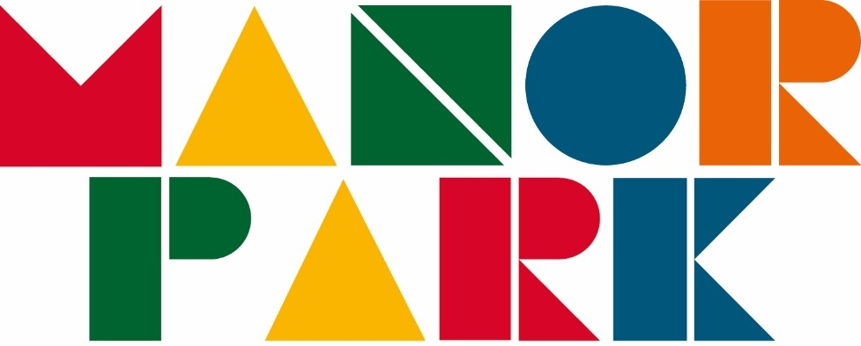

The Phonics Policy in respect of Manor Park Primary School has been discussed and adopted by the Governing Body

Last updated: March 2020
To be reviewed: March 2023

Phonics Policy

PERSON RESPONSIBLE FOR POLICY: | Suzanne Devenport
APPROVED:
signed:
to be reviewed: | March 2023

Introduction
Our pupils learn to read and write effectively and quickly using the Read Write Inc. Phonics programme. Phonics is the key to unlocking the alphabetic code of the English language. The acquisition and development of phonic skills are therefore regarded as being of the utmost importance. The teaching of Phonics is given a high priority.

Aims
In Read Write Inc. Phonics pupils:
- Decode letter-sound correspondences quickly and effortlessly, using their phonic knowledge and skills
- Read common exception words on sight
- Understand what they read
- Read aloud with fluency and expression
- Write confidently, with a strong focus on vocabulary and grammar
- Spell quickly and easily by segmenting the sounds in words
- Acquire good handwriting

In addition, we teach pupils to work effectively with a partner to explain and consolidate what they are learning. This provides the teacher with opportunities to assess learning and to pick up on difficulties, such as pupils poor articulation, or problems with blending or alphabetic code knowledge.

Organisation
We group pupils homogeneously, according to their progress in reading rather than their writing. This is because it is known that pupils’ progress in writing will lag behind progress in reading, especially for those whose motor skills are less well developed.

At Manor Park, Read Write Inc. Phonics is taught in the summer term in Nursery, then in Reception and Year 1. Pupils in Year 2 who don’t pass the Phonics Screening check and pupils in KS2 who need to consolidate their phonics skills are included in phonics teaching and placed in an appropriate Read Write Inc. Phonics group.

In Reception we emphasise the alphabetic code. The pupils rapidly learn sounds and the letter or groups of letters they need to represent them. Simple mnemonics help them to grasp this quickly. This is especially useful for pupils at risk of making slower progress. This learning is consolidated daily in addition to the group teaching e.g. in Reception - regular ‘Fred Talk’ (oral blending) and Speed Sound card recognition and in Year 1 – an extra 10 minute Phonics session in the afternoon focusing on Set 2 and Set 3 sounds and green word cards. Pupils have frequent practice in reading high frequency words with irregular spellings – common exception words.

We make sure that pupils read books that are closely matched to their increasing knowledge of phonics and the common exception words. This is so that, early on, they experience success and gain confidence that they are readers. Re-reading and discussing these books with a member of staff supports their increasingly fluent decoding. Shared reading takes place daily straight after the phonics session. Pupils read appropriate Read Write Inc. Phonics storybooks matched to their phonetic ability. Alongside this, the staff read a wide range of stories, poetry and non-fiction to pupils.

Embedding the alphabetic code early on means that pupils quickly learn to write simple words and sentences. We encourage them to compose each sentence aloud until they are confident to write independently.

Pupils write at the level of their spelling knowledge. The quality of the vocabulary they use in their writing reflects the language they have heard in the books the staff have read to them; they have also discussed what the words mean.

Our aim is that once the pupils have completed the phonics programme they will be able to choose books to read at their own interest and comprehension level.

Assessment and tracking progress
We assess all pupils following Read Write Inc. Phonics using the Entry Assessment. We use this data to assign them to a Read Write Inc. Phonics group. We do this for all pupils in Reception and Year 1, whenever they join us, so we can track them all effectively, including those eligible for pupil premium. We enter the assessment data on the assessment tracker to monitor the rate at which they are making progress.

We aim for all children to be accurate and speedy readers by the time they enter Key Stage 2.

Pupils who are making slower progress (as identified from the assessment tracker) and pupils with special educational needs receive one-to-one tuition daily. Trained staff tutor them for 10 minutes every day using the Read Write Inc. One-to-one tutoring programme, in addition to their group phonics session in the morning. This tutoring helps us to meet their individual needs. If a child arrives in Key Stage 2 reading below their chronological age or with English as an additional language, they are taught Read Write Inc. Phonics until they too catch up with their peers.

By the end of Key Stage 1, our pupils are able to read aloud age-appropriate texts accurately and with sufficient speed for comprehension. This means we can focus on developing their comprehension, preparing them well for transition to Key Stage 2. Their good decoding skills mean that they have a sound strategy for decoding unfamiliar words when they come across them at whatever stage or in any subject.

Quality of teaching, learning and assessment
The Read Write Inc. Phonics programme has a ‘cycle of instruction’ which means that, after direct instruction and guided practice, the pupils teach another pupil. In this way they all rehearse and consolidate what they have been learning. This helps the pupils to make their understanding clear to themselves and helps the staff deal with any misconceptions. ‘Partner teaching’ is a key assessment tool in Read Write Inc. Phonics. ‘My Turn, Your Turn’ and ‘Turn to Your Partner’ are key strategies of each Phonics lesson.

In Read Write Inc. Phonics, because the pupils are grouped across Key Stage One in terms of their reading ability, they are reading at an appropriate decoding level every day. The homogeneous groups in the Phonic lessons help us to focus teaching and ensure pupils learn to read quickly.

The Reading Leader assesses all children every 6 weeks. The assessment data allows us to intervene in different ways. For instance, we move pupils to another group if they are progressing faster than their peers. Those who continue to struggle have one-to-one tutoring so that they keep up.

All the pupils are engaged, with a positive impact on their behavior. They learn to participate fully: we agree with them the rules for working in a group or discussing with a partner. We use the Read Write Inc. Phonics hand signals. We discourage ‘hands up’ for answering questions because we believe that all pupils should answer every question. The teacher selects pupils to answer. We use silent Read Write Inc. Phonics signals for gaining attention, for setting up partner routines, and for managing the way pupils move around the classroom. Everyone teaching Read Write Inc. Phonics uses the same signals.

The Read Write Inc. Phonics programme has detailed lesson plans. These give the staff practical day-to-day guidance, but we work hard to build on these plans so that lessons are matched carefully to the needs of their particular group. Every activity is prepared thoroughly and has a clear purpose. Staff explain this at the beginning so that the pupils understand, during the activity, what they are learning and why.

We emphasise constructive feedback. We praise pupils for how hard they work together to ensure that their learning is successful. We have clear systems for marking pupils’ work in line with the whole school ‘Marking and Feedback’ policy.

Parents
The school recognises the importance of the parental role in a child’s reading development and places particular emphasis on building a strong home/school partnership. Parental support will be sought and valued from the earliest stages in school. Pupils will take books home on a daily basis to share and enjoy with their family. Pupils will take home books that are fully decodable and at the appropriate level for their phonetic ability this ensures that all pupils will be able to access these books independently at home. Pupils also take home familiar picture books so that parents / carers can read to the children and they can then re-tell the story out loud and recall details and vocabulary.

Parents / carers are encouraged to make regular comments in the child’s reading diary. Information about the school’s approach to phonics and reading will be given to parents / carers via; meetings / workshops / Stay and Play events, leaflets etc.

Role of the Reading Leader
The headteacher works closely with the reading leader to monitor the quality of teaching. The role of the reading leader is critical to drive the teaching of Read Write Inc. Phonics. The reading leader’s roles include:
- Ensuring that our teaching of reading in Reception and Year 1 is of the highest quality and that all our pupils make progress
- Ensuring pupils in the ‘lower progress’ groups are making good progress and organising one-to-one tuition for the pupils who need extra support
- Keeping the groups homogeneous, i.e. at the same level
- Assessing all the pupils on the Read Write Inc. Phonics programme every 6 weeks
- Providing further training through coaching within the phonics lessons and weekly group practice sessions

The reading leader can give this support every day because she doesn’t teach a group herself. Staff alert the reading leader to any pupil whose progress is faster or slower than the rest of the group.

The reading team is made up of a team of teachers and teaching assistants who each teach a group of pupils at the same reading level. All the reading team have attended two-day Read Write Inc. Phonics training. The reading leader regularly coaches staff in Read Write Inc. Phonics lessons. All of the reading team attend a weekly 30-minute practice session with the reading leader where they practice the teaching steps of Read Write Inc. Phonics. The reading leader keeps a record of coaching and practice sessions.

SEND and Equal Opportunities
Those children who are identified as: having a SEN or needing extra support will receive daily one-to-one tuition. Our policy is monitored to ensure that all children have equality of access to a range of reading books and experiences so that all children achieve to the best of their potential regardless of gender race or culture.

